AIM
Activity Customer Creation Inbound
MD.120 deployment Instructions

Author: Rahul Vardhan
Creation Date: JUNE 05, 2024
Last Updated:
Version: 1.0

Title, Subject, Last Updated Date, Reference Number, and Version are marked by a Word Bookmark so that they can be easily reproduced in the header and footer of documents. When you change any of these values, be careful not to accidentally delete the bookmark. You can make bookmarks visible by selecting Tools->Options…View and checking the Bookmarks option in the Show region.

Approvals:
<Approver 1>
<Approver 2>
To add additional approval lines, press [Tab] from the last cell in the table above.
 Copy Number _____
You can delete any elements of this cover page that you do not need for your document. For example, Copy Number is only required if this is a controlled document and you need to track each copy that you distribute.

Document Control

Change Record
3
Date | Author | Version | Change Reference
 |  | Ver 1.0

Reviewers

Name | Position

Distribution

Copy No. | Name | Location
The copy numbers referenced above should be written into the Copy Number space on the cover of each distributed copy. If the document is not controlled, you can delete this table, the Note To Holders, and the Copy Number label from the cover page.

Note To Holders:
If you receive an electronic copy of this document and print it out, please write your name on the equivalent of the cover page, for document control purposes.
If you receive a hard copy of this document, please write your name on the front cover, for document control purposes.
Contents
Document Control ii
Create Connections for ACTIVITY Customer Creation 1
Creation Of FTP : 1
Creation Of REST Api Connection For Creating Customer: 2
Creation Of Integration: 3
List of files: 4
Read a file 7
Rest connection 8
Open and Closed Issues for this Deliverable 14
Open Issues 14
Closed Issues 14

To update the table of contents, put the cursor anywhere in the table and press [F9]. To change the number of levels displayed, select the menu option Insert->Index and Tables, make sure the Table of Contents tab is active, and change the Number of Levels to a new value.

Create Connections for ACTIVITY Customer Creation
Creation of Connections:
- For Activity Apply Customer Creation we are using two Adapters Restapi and Winscp (server)
- To create connections, navigate to connections tab and select create option then select desired adapter as shown below.
Adapter :- it helps to store the required credentials to make a connection.

Creation Of FTP :
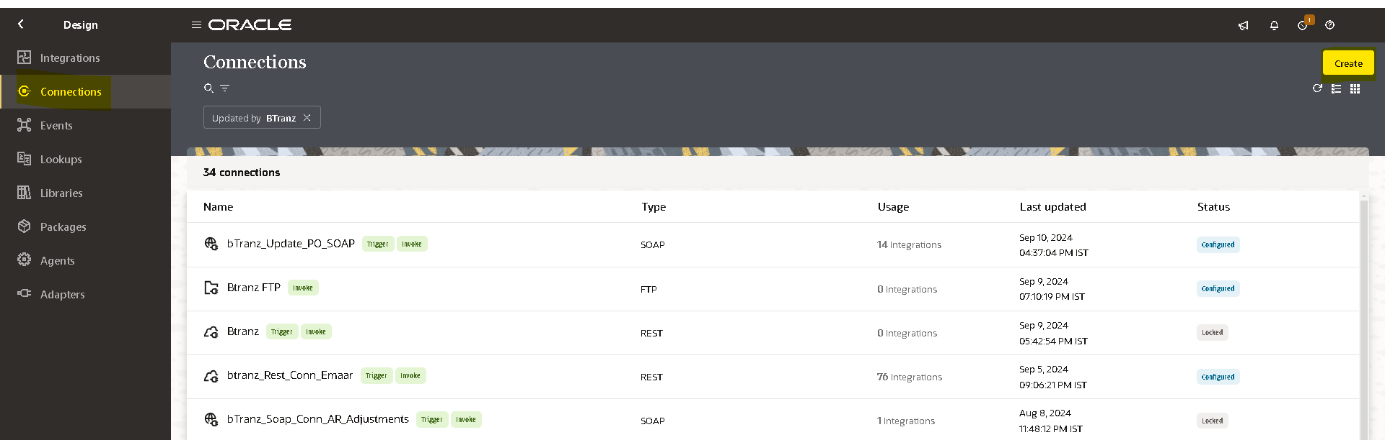
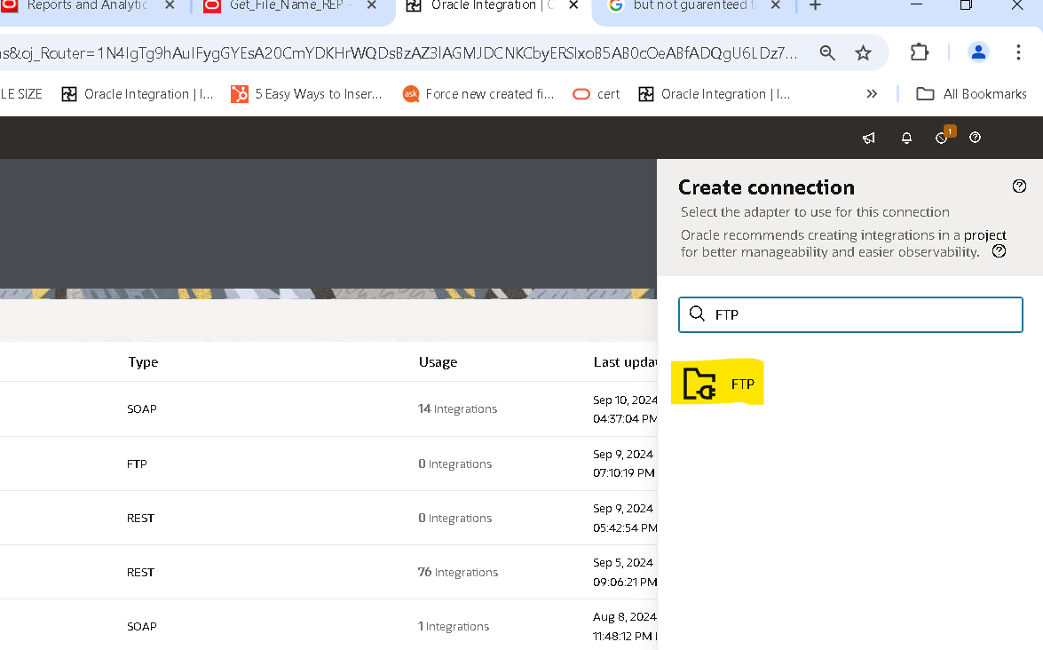
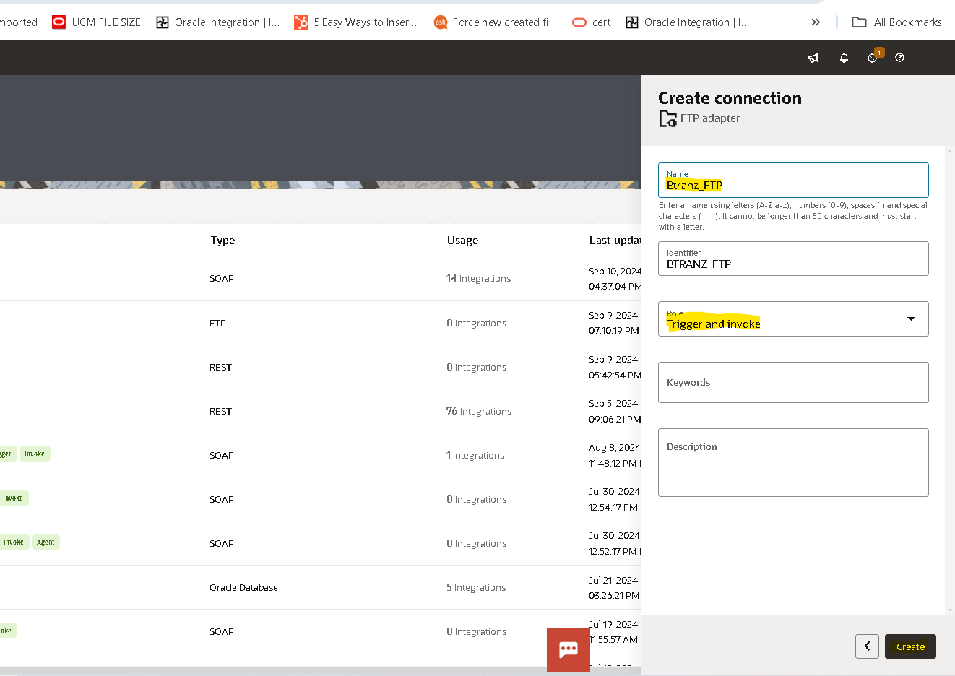
Connection Role :- a trigger means the connection where the integration receives the message. An invoke means the connection where the integration sends the message.
- Based on our requirement we choose trigger and invoke role connection.
- After clicking on create we need to pass the required Data along with the login credentials.
- Click ‘Yes’ in SFTP Connection in Optional Properties.
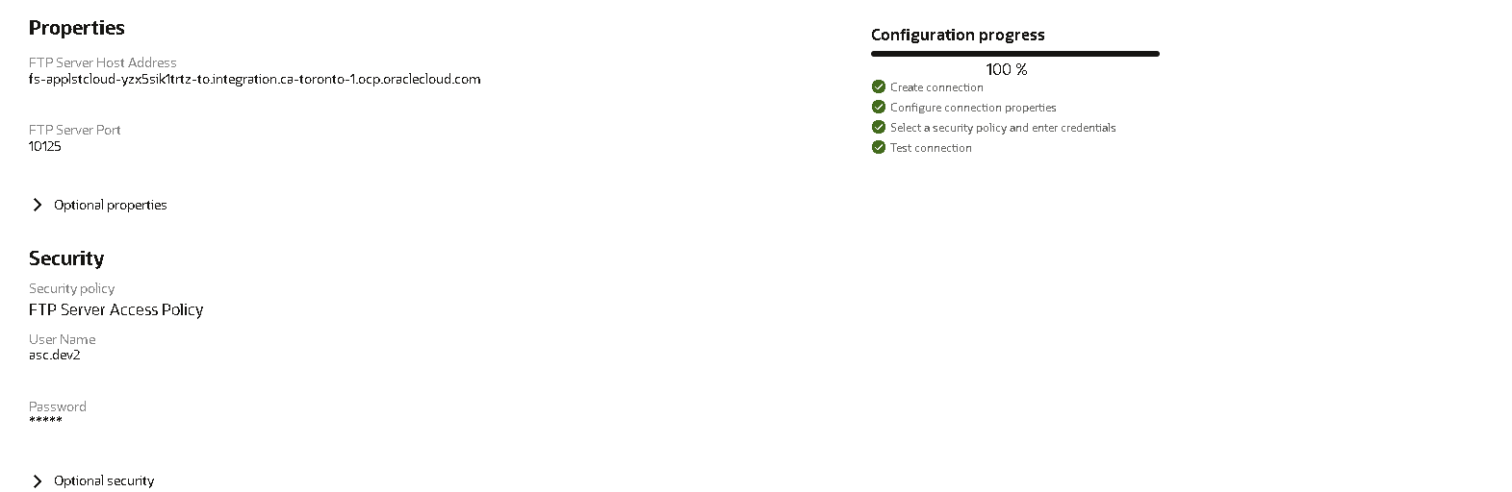
- Then click on test,popup will appear as shown above then select diagnose & test.
- After successful testing save your connection.
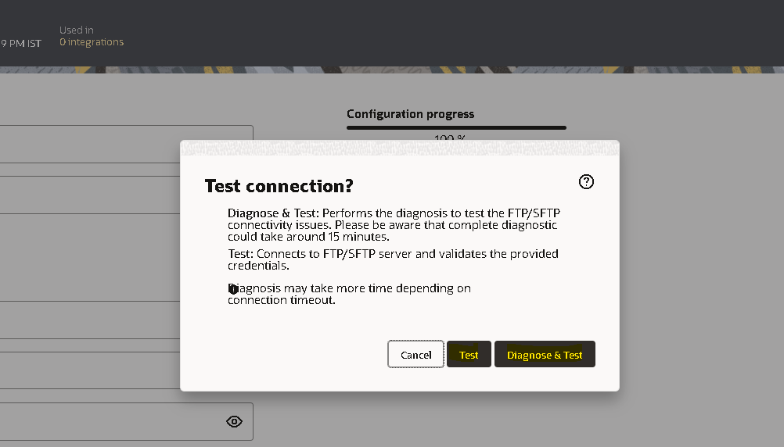

Creation Of REST Api Connection For Creating Customer:
role trigger and invoke
- Navigate to connections tab then select the adapter based on the connection(Rest)
- Rest Connection : - https://fa-epxp-test-saasfaprod1.fa.ocs.oraclecloud.com.
- Enter the Rest URL and select security as basic authentication and enter fusion credentails as username and password.
- Then click on test, after testing successfully save the connection.
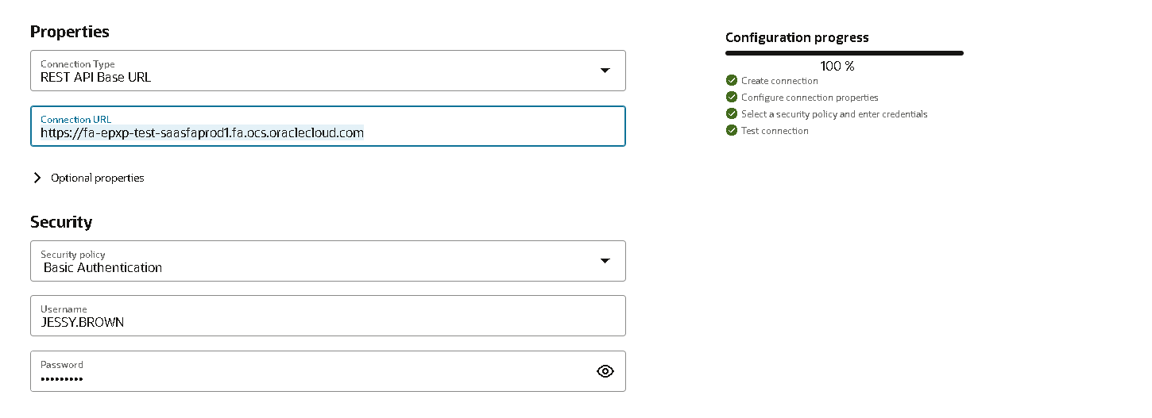

Creation Of Integration:
- Click on Design and select the integration and Click on Create .
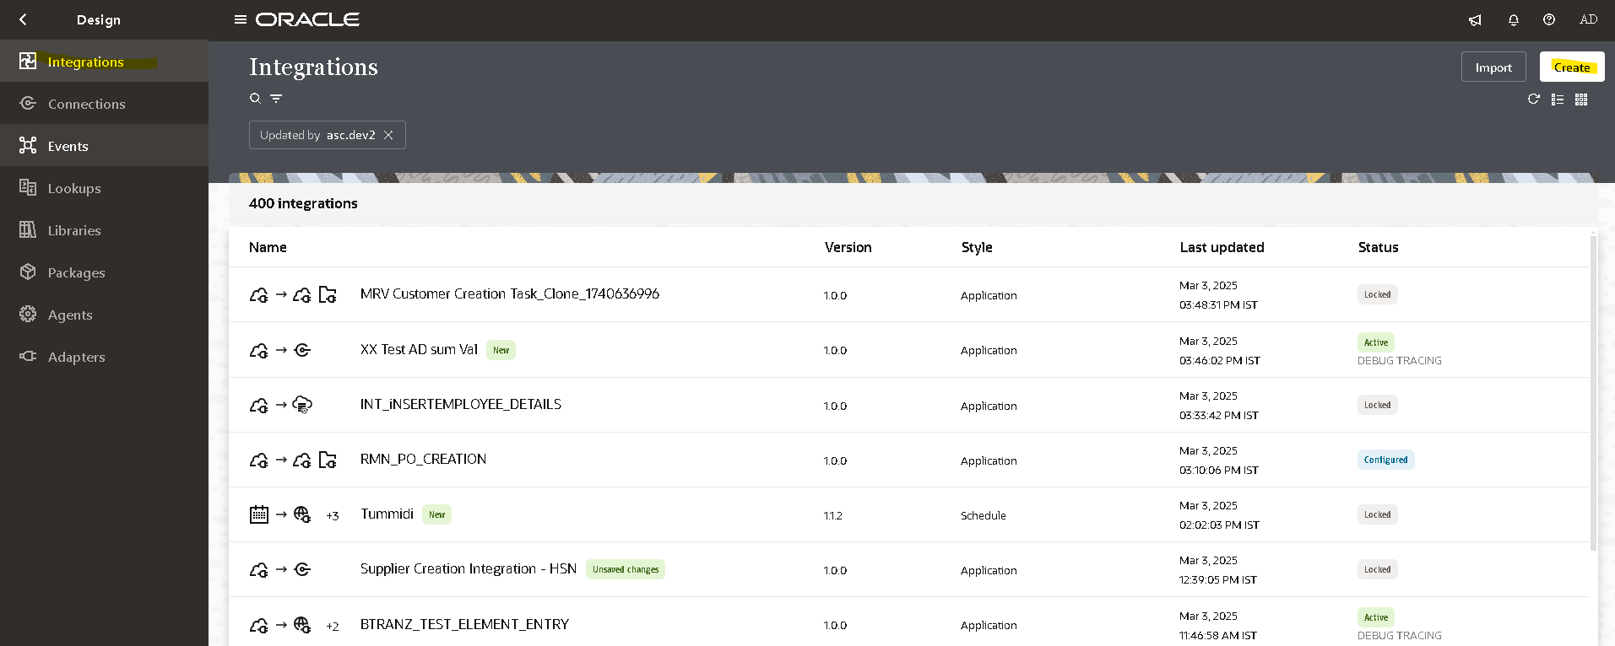

- Try to create with a unique name for identification.
- Select the application to create integration
- Fill the name, Identifier and if includes then Package.

- Select the sample rest connection and create the rest connection.
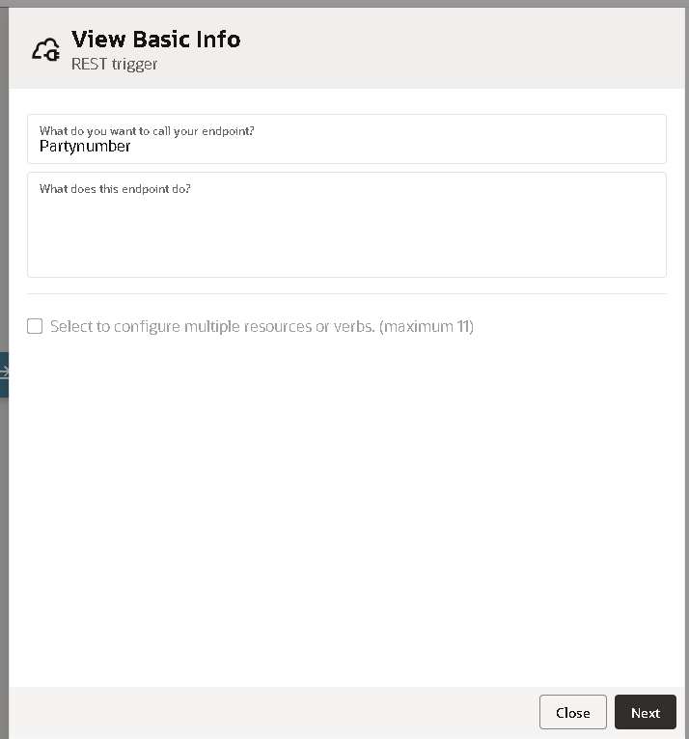
- Select the method as GET as give the response as shown below.
- Configure this endpoint to receive the response.
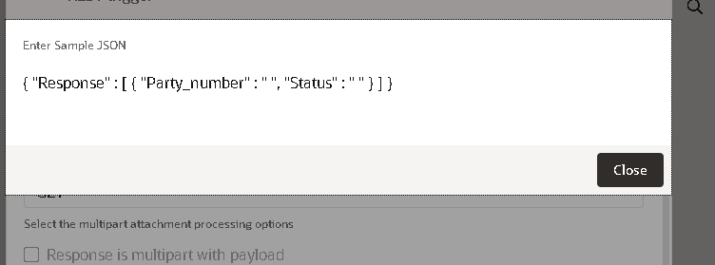

- Next assign the variables to it.
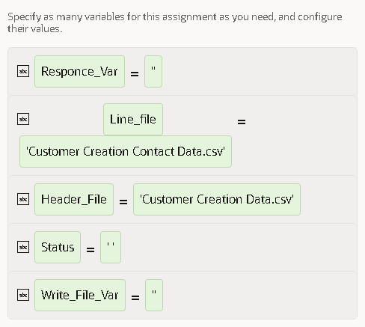
- Assign the variables to it.

- Add the sftp connection.

List of files:
- Select the list of files in the winscp .

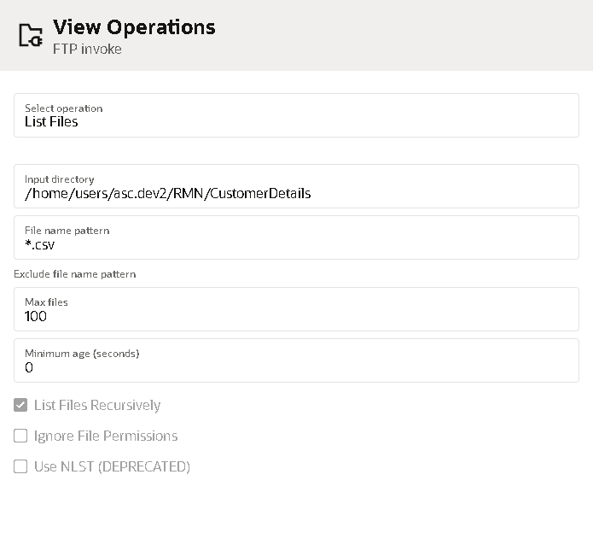

- Select the approiapriate directory in Winscp and select file name pattern as *.csv which includes all the files in it.

- Map the listfile as select the file name pattern and directory
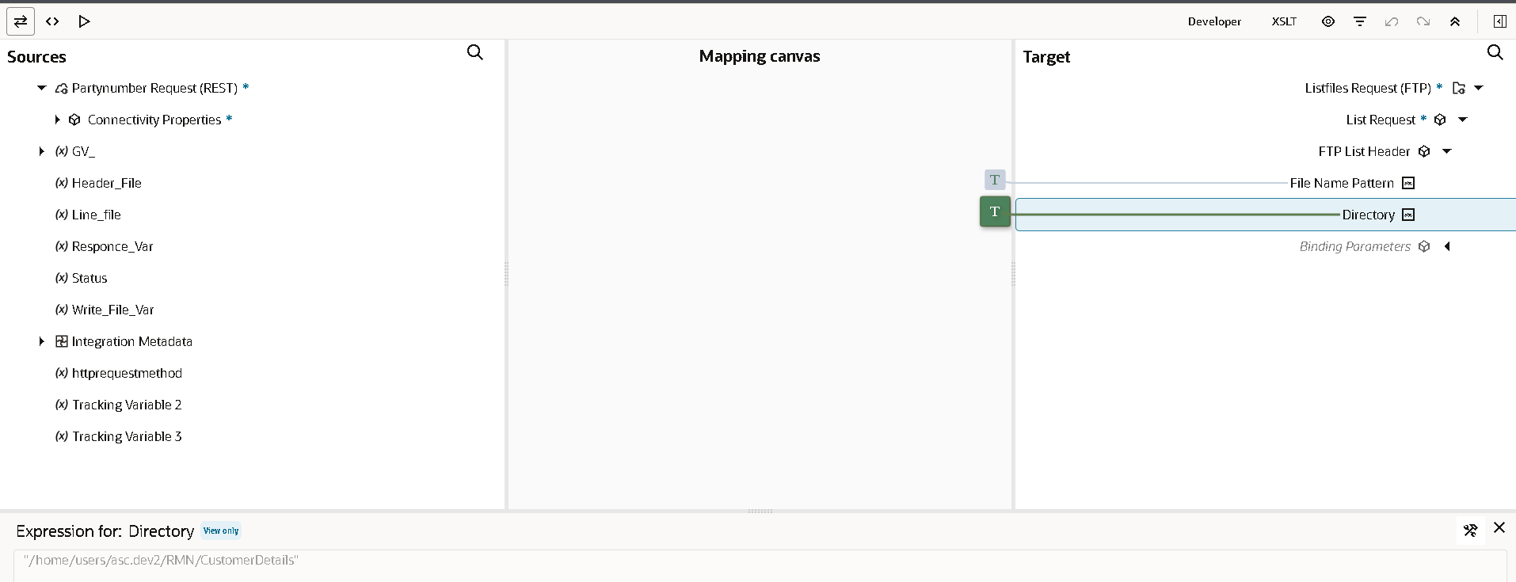

- Name the ftp connection appropriate to your integration for better understanding. As we are listing the number of files in source dir, so we used the List_Files operation.

- Use the switch connection after it if required file is exists then goto integration or else end to mapper and it results that file doesn’t exists.
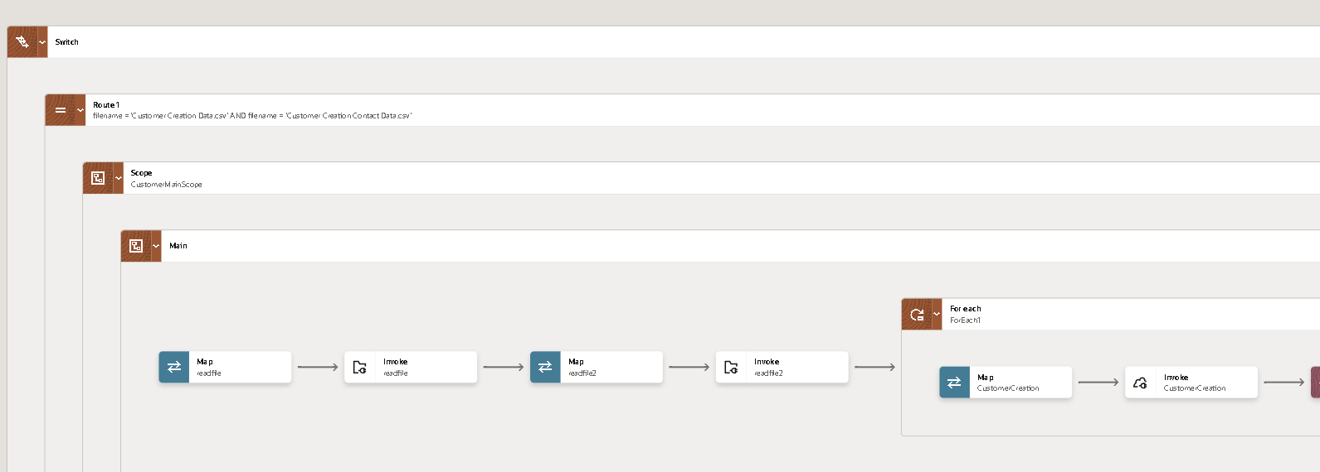
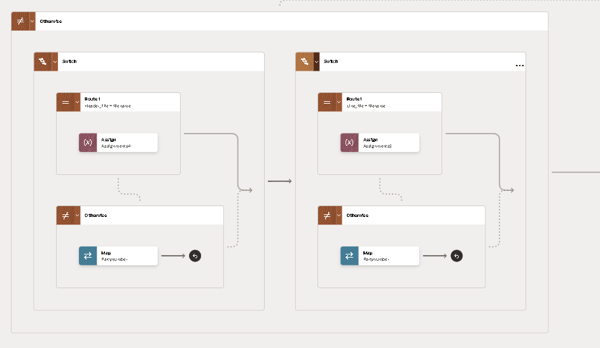

- Then check the filename if exists then go to the integration.
- Then write the scope to start the integration.
- We need to add a scope as we can handle any errors within scope without disturbing whole integration.
- Then read the file in it.
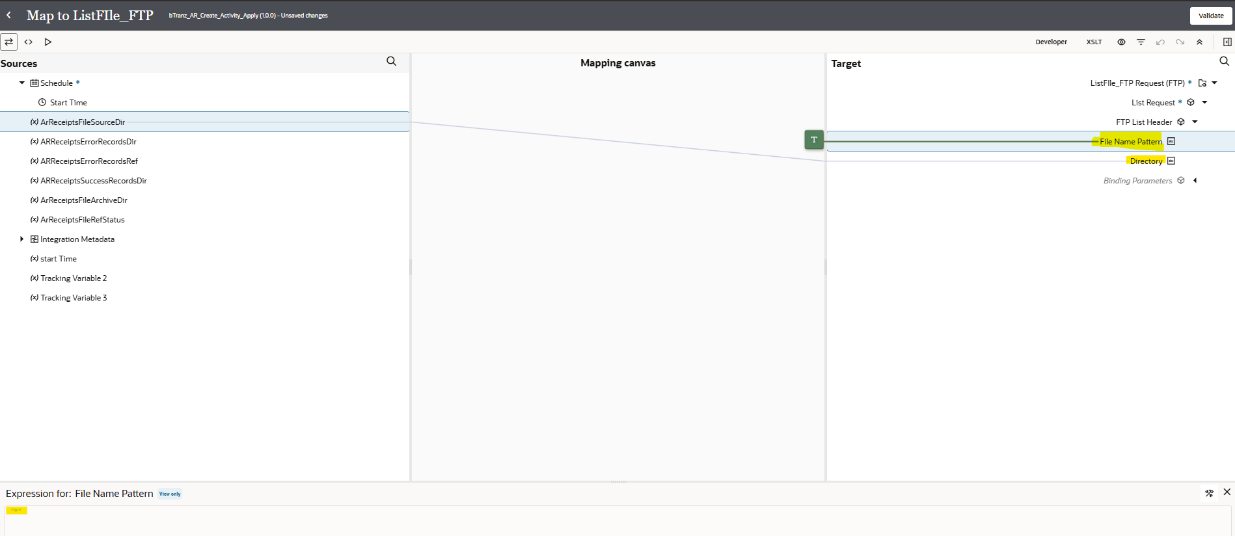
- Then read all the files
- We used to read all the files of lines or headers.

Read a file
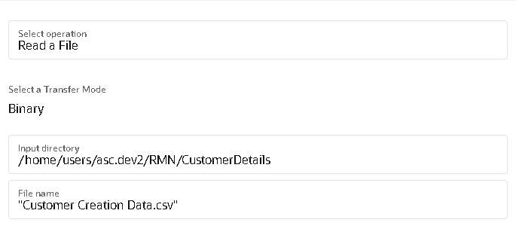
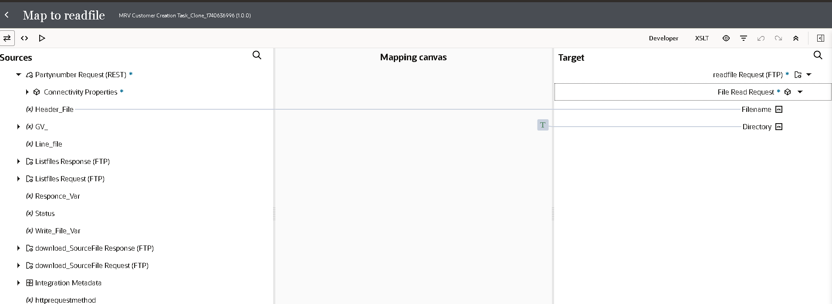

- Select the repeating element into it for the header file record to run it multiple times
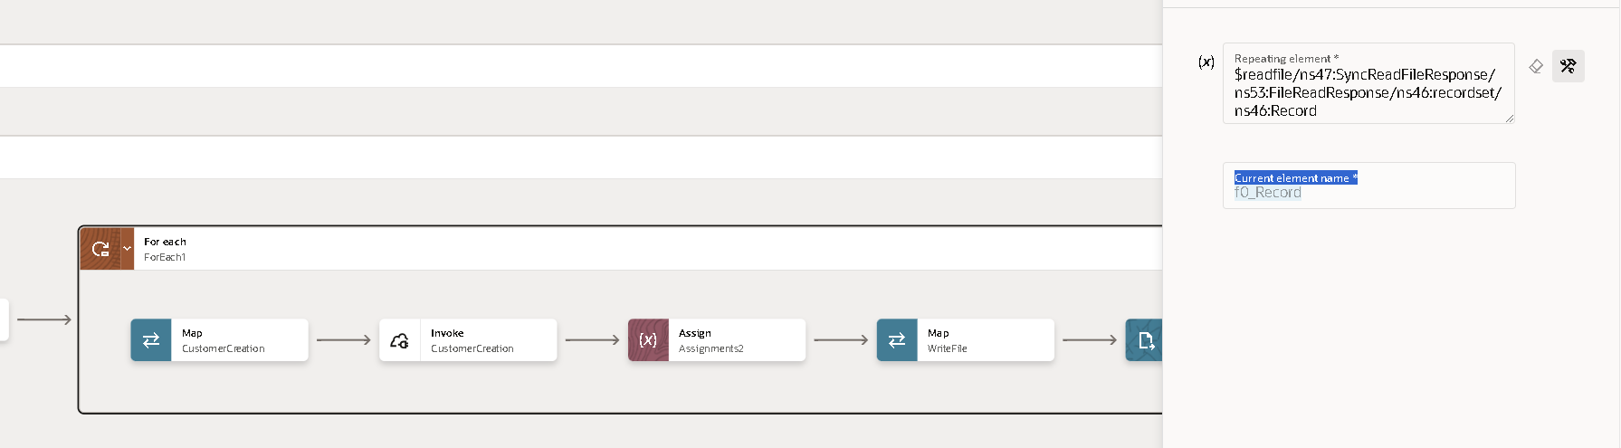

- Now we need to use ‘For Each’ action as we need to iterate each file.
- Click on plus (+) icon and search ‘For Each’.
- We will use the repeating element as the file which we got as a response from the read file operation.
- Drag the file to the repeating element and click on create.

Rest connection
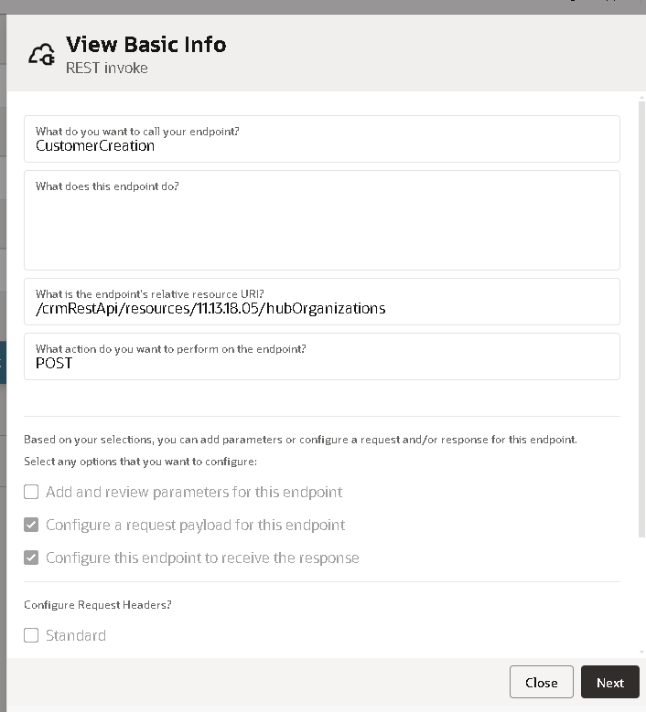

- Calling the rest api with this url.
- Create the invoke connection of customer creation.
- Assigning the read files columns to the fields.
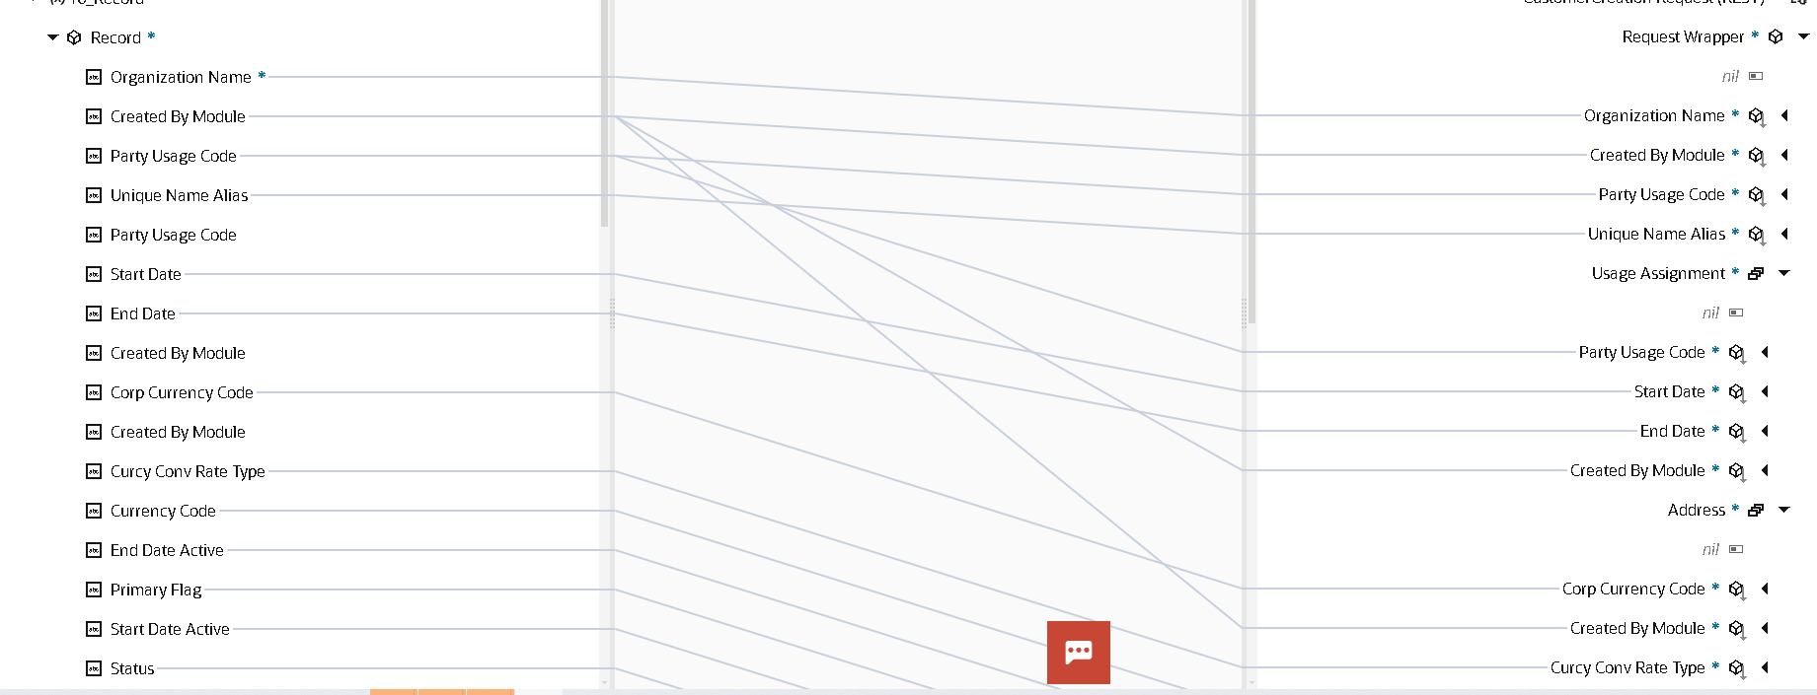
- Catching the party number in assignment variable.
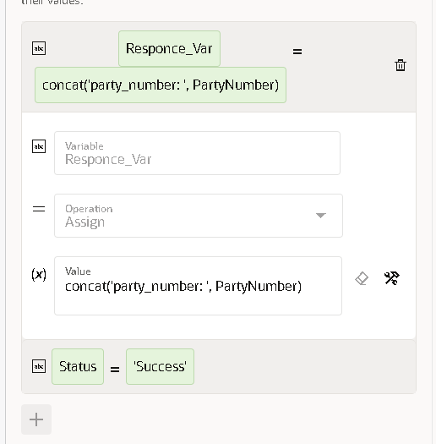

- We will map the input directory and file name later with the response of the For Each. As of now we are assigning it.
- Creating the stage file of write to catch the multiple party number and show in the output.
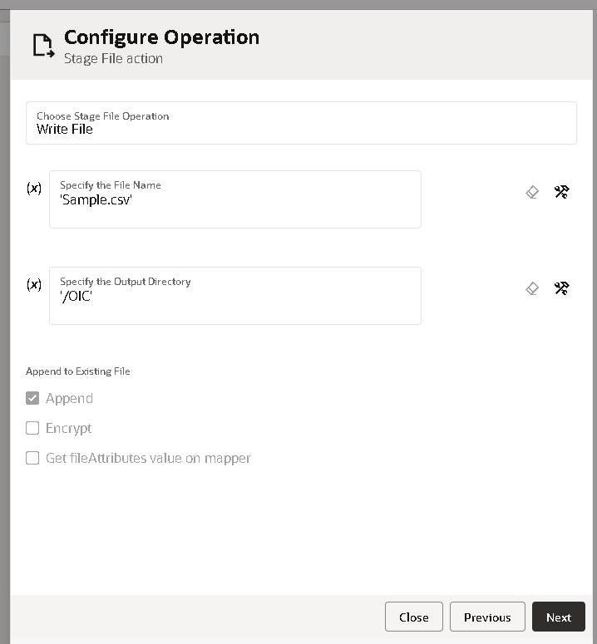
- Click on the append to catch the solutions

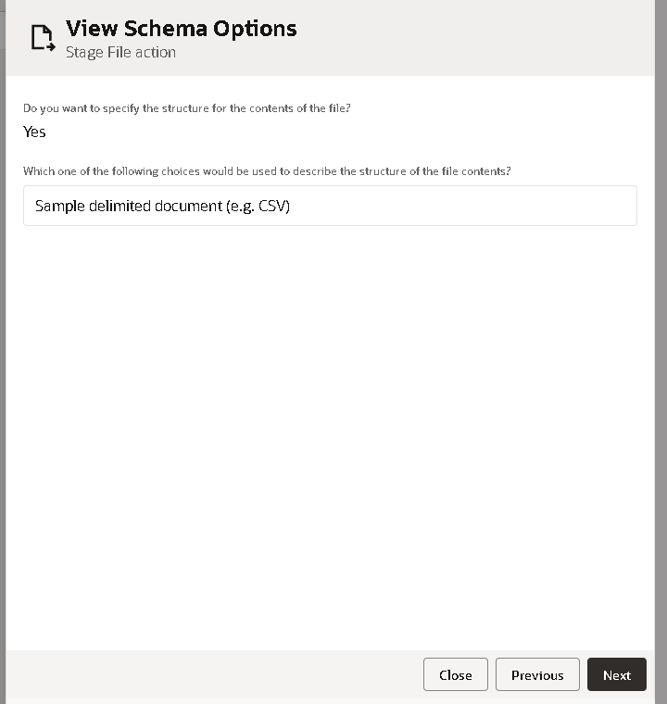
- Select the sample csv and load the file.
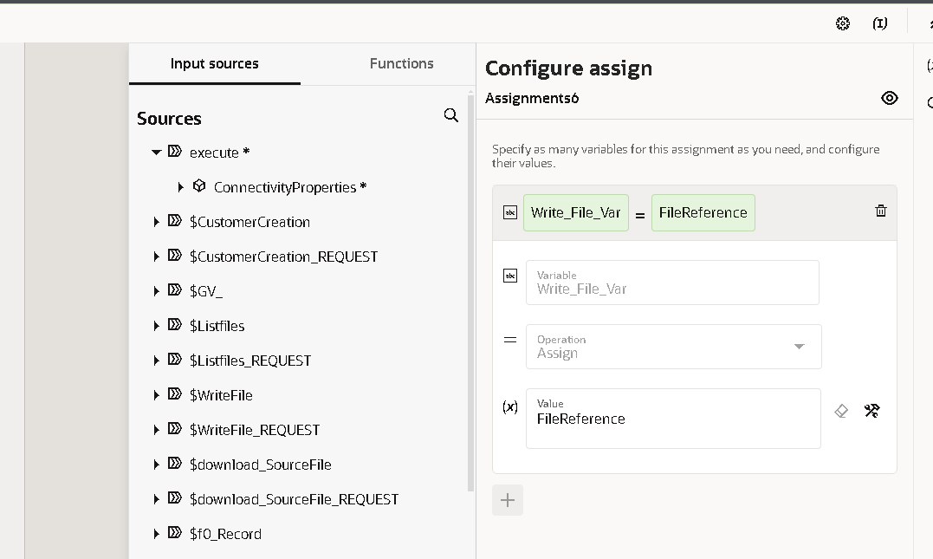
- Assign the variable to catch the response of file reference.
- Assign to that variable to catch the response and use in the map.
- To write the file in the oracle r12.
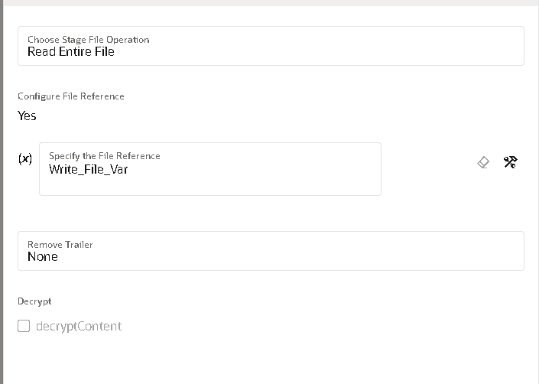

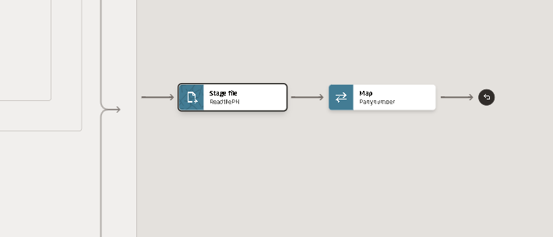
- Now we will use the stage activity to read the file from the response.
- Search for ‘stage’ adapter by clicking on the plus (+) icon.
- Select the operation as ‘read File In Segments’. And configure file reference as yes.

- Now we need to give the structure of the file content. As we are using the csv file select reference file from download response.
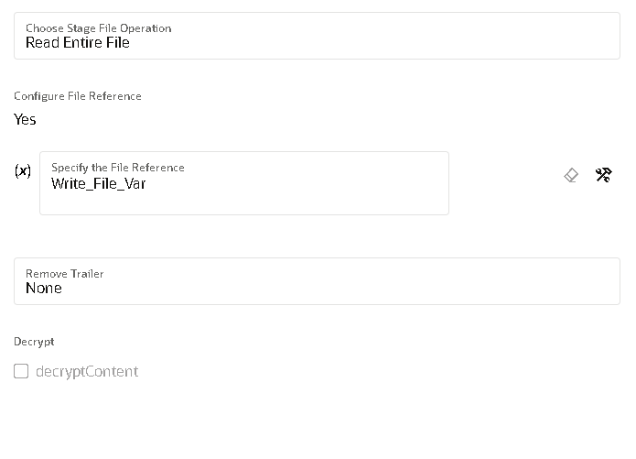

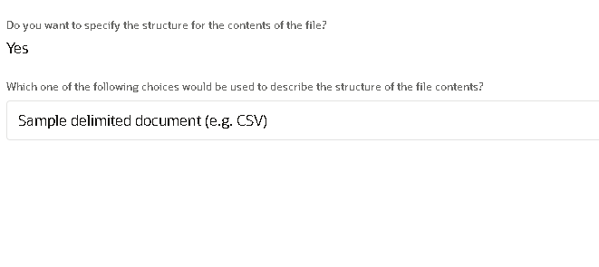
- We need to give sample structure format of the file.
- Here choose the file from your local desktop and you can mark all as optional but at least one column should be mandatory.
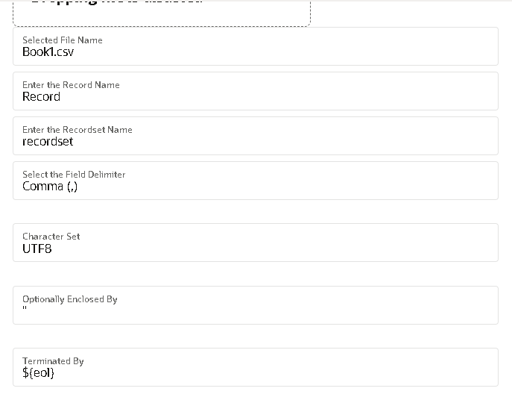

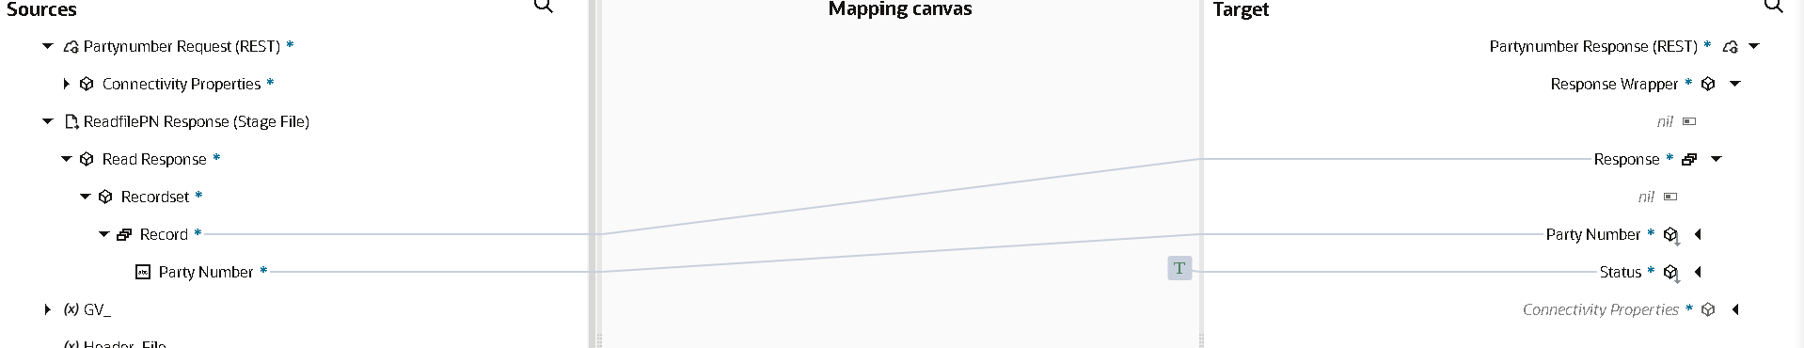

- To call the party number column in the outer map.
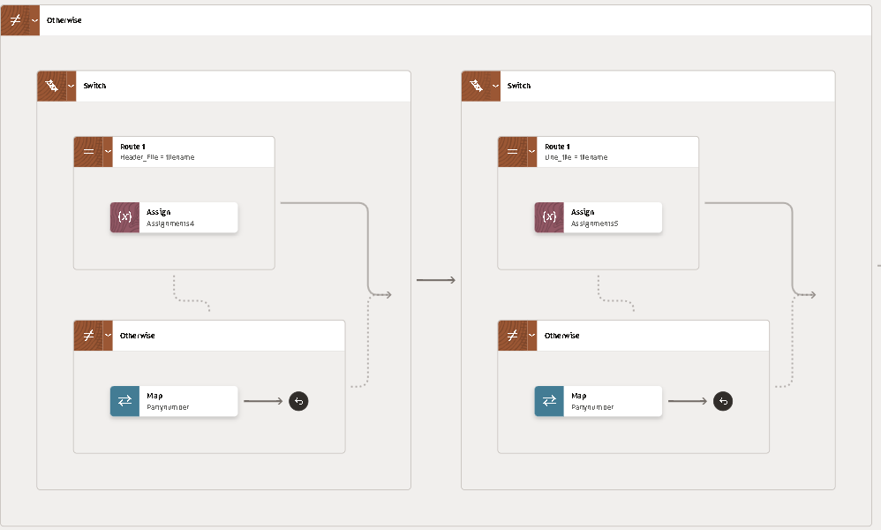

- Otherwise in switch is used to check both the files exist in winscp.
- The map will end when it doesn’t exist.

The overall integration for the customer creation integration:
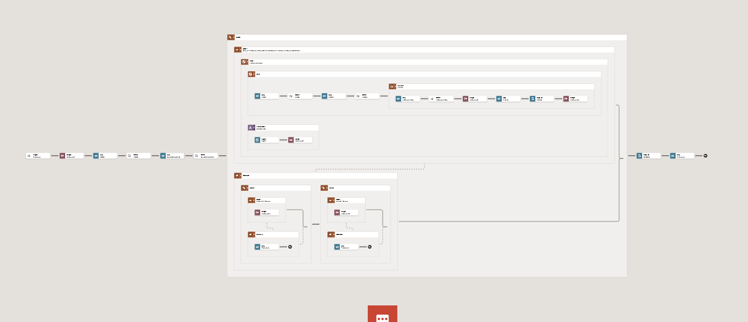
The name in the integration is MRV Customer Creation Task_Clone_174063699.

After activation of the oic then we have to run the integration.
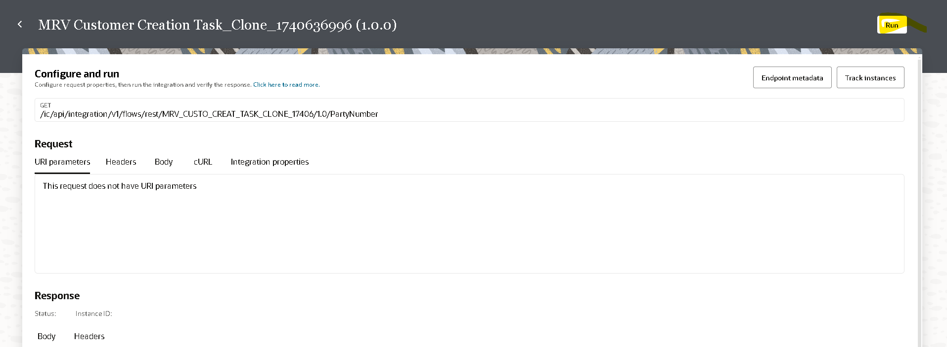

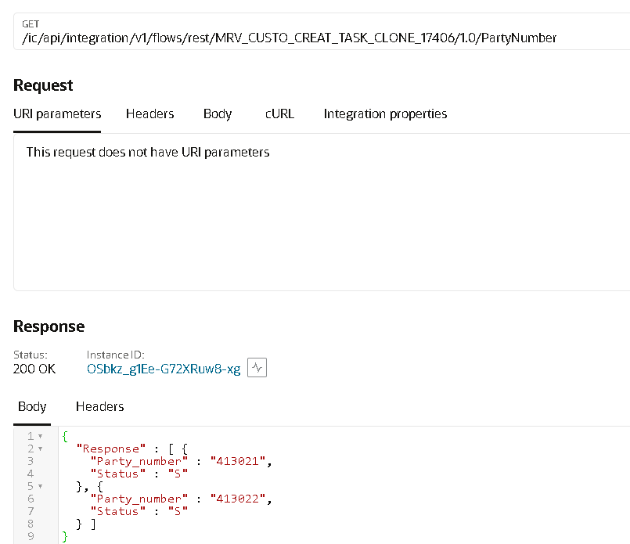
Here we get the response like this.

The Integration File for Customer Creation is:

Open and Closed Issues for this Deliverable

Open Issues

ID | Issue | Resolution | Responsibility | Target Date | Impact Date

Closed Issues

ID | Issue | Resolution | Responsibility | Target Date | Impact Date

